Supplementary Information
Preparation of catalyst from natural montmorillonite mineral and its application in the synthesis of carbon nanosphere

*Corresponding Author: Altantuya Ochirkhuyag (Orchid ID: 0000-0001-6495-7360 )
altantuya_o@mas.ac.mn

General composition of Humeltei montmorillonite mineral is shown in Figure S1.
Figure S1. Chemical composition of Humeltei deposit clay mineral (Montmorillonite).

Elemental analysis of the samples shown in Figure S2.
Figure S2. Elemental analysis result of the samples.

TEM image of the catalyst/support Fe-SiO₂ is shown in Figure S3.
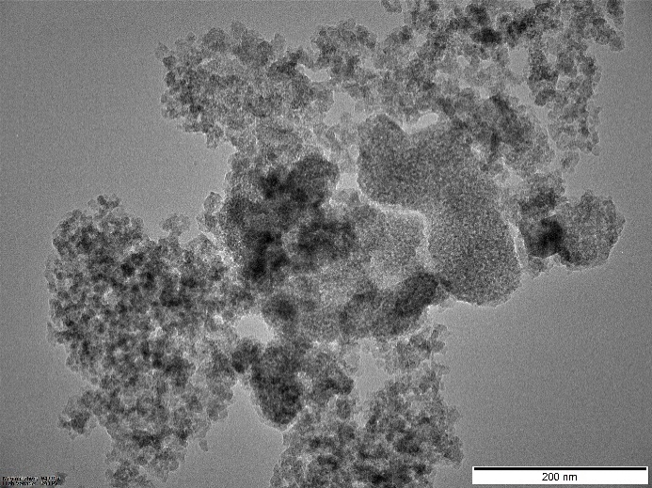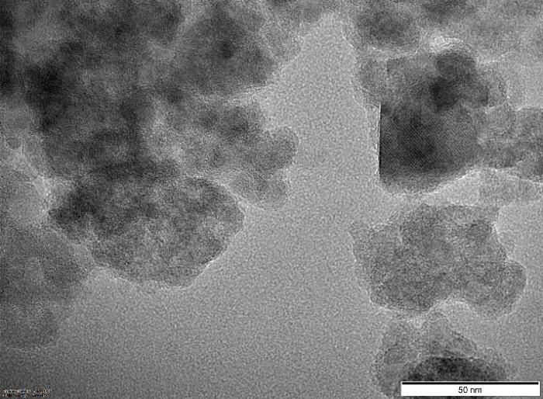
Figure S3. TEM image of the Fe-SiO₂ catalyst.

Pluronic F68 and CNS sample showed that CNS dispersion in water.
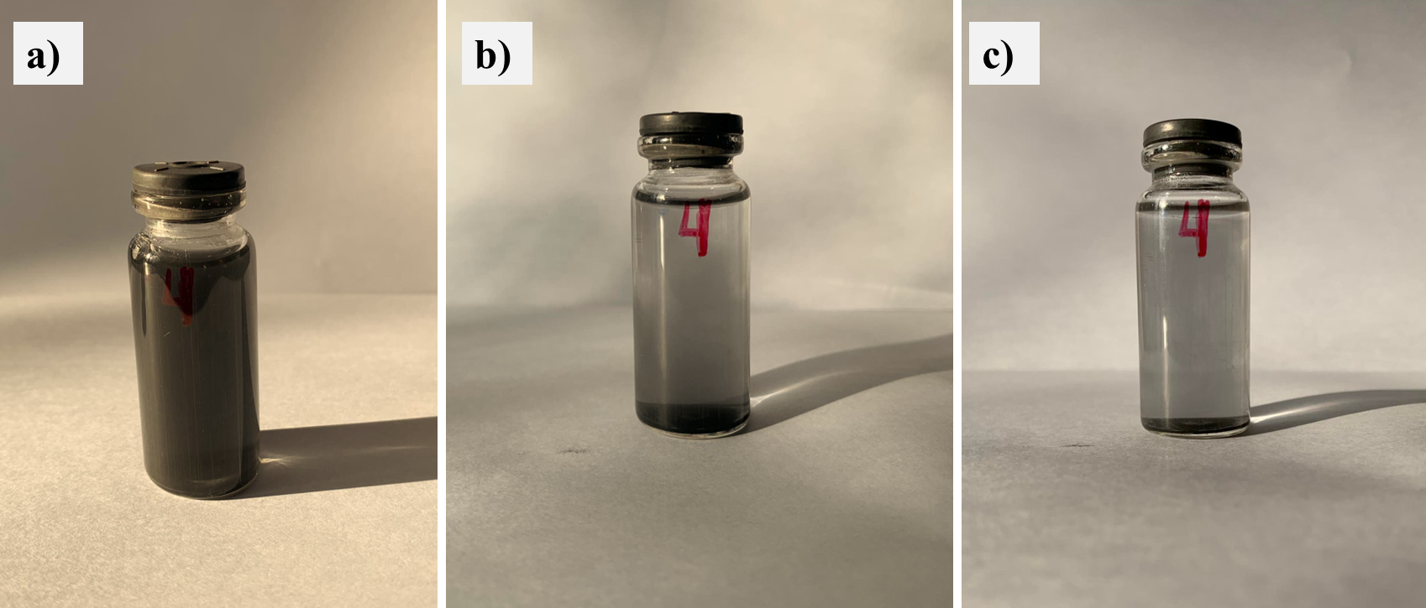
Figure S4. CNS+Pluronic F68 surfactant suspension after 1 hour sonication (a), 24 hours (b) after and 48 hours (c) after.

